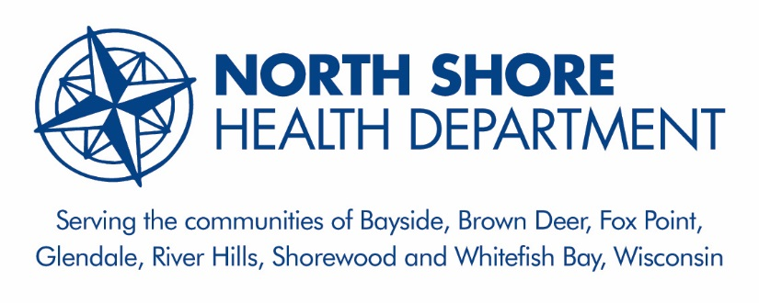 | Board of Health

2010 E. Shorewood Blvd.
Shorewood, WI 53211

August 24th, 2017

The North Shore Board of Health meeting was called to order on May 18th, 2017 at 7:02 pm by Ann Christiansen.

- Roll call
Present:, Barbara Bechtel, RN, BSN, Debesh Mazumdar, MD, Bill Warner, Christopher Simenz, PhD, and Ann Christiansen, MPH.
Absent: Claudia Altman, MD, Mary Jo Baisch, PhD, RN, Jennifer Eversen, MS, Gary Lewis, MD
- Persons Desiring to be heard
There were no persons desiring to be heard.

- Approval of May 18rd Minutes
Dr. Mazumdar made a motion to approve the minutes from May 18th, 2017; the motion was seconded by Mr. Warner and approved.

- Health Department Administrative Items
  - Review NSHD Strategic Plan and discuss potential updates to the goals.
Ms. Christiansen requested that given our work to create a Workforce Development Plan that we add an objective to our Strategic Plan. The Board agreed to consider a new objective for the Plan at the October meeting.

  - Review Performance Management System
Ms. Christiansen presented the Performance Management tracking system to show progress towards NSHD Strategic Plan goals and objectives. Indicators measuring Priority 1, Advance the Quality and Performance of the North Shore Health Department were on track. The Code of Ordinance pertaining to Food, Lodging, Recreational Safety, and Licensing was passed by all seven communities. Indicators for Strategic Priority II, Provide High Quality Public Health Programs and Services to North Shore Residents are also on track. These indicators largely reflect grant and program objectives and most were on track to be met. For Strategic Priority III, Engage community members, leaders, and stakeholders in initiatives to advance the health priorities identified in the Community Health Improvement Plan. The Health Department has not yet established a coalition to oversee the Community Health Improvement plan. This will likely be created once the health assessment is complete and results have been disseminated. We continue to be active in local, regional, and county groups focused on our health priorities to maximize our impact. The Health Department will continue to use the Board of Health as the group who oversees progress in this area.

  - Update on Funding Formula discussion with Managers/City Administrator
Ms. Christiansen said there were no additional updates on this issue since the previous meeting.

  - Discuss 2018 DHS grant projections, including potential cuts to Public Health Emergency Preparedness funding.

Ms. Christiansen updated the BOH on recent discussions about potential cuts to the CDC’s Public Health Emergency Preparedness Program budget. The President recommended a 17% cut to CDC’s budget and for CDC to look into reviewing its formula for allocating funds to states. Ms. Christiansen discussed that 12% of the NSHD’s total funding is from these federal funds. If there are significant decreases, this would have a large impact on our ability to prepare, respond to, and recover from a public health emergency. The Board advised Ms. Christiansen to write a letter to the Wisconsin Department of Health Services’ Secretary. The letter would contain local stories about how our health department uses these funds to improve our preparedness and to improve the health and safety of people in the North Shore.

- North Shore Environmental Health Consortium
  - Update on approval of the revised Food Safety and Recreational Licensing ordinance
Ms. Christiansen updated the Board on the final passage of the Food Safety and Recreational License in Fox Point on August 8th, 2017. All communities have now adopted the ordinance.
  - Update on program staff
Ms. Christiansen updated the Board on the promotion of Brad Simerly to Senior Environmental Health Specialist. We have also begun recruiting for a part-time Environmental Health Specialist in response to feedback from our Program Evaluation with the Department of Agriculture, Trade, and Consumer Protection.
- Reports and Discussion
  - Disease Control and Prevention – Review mid-year communicable disease data for North Shore.
Ms. Christiansen provided an update on current numbers and types of communicable diseases the NSHD has responded to for the first part of 2017. Overall, we have responded to 279 confirmed and probable cases compared to 304 in 2016. The disease cases have been unique in 2017 with more food and water-borne disease cases.

  - Environmental Health - Asking the Questions Parent Survey Results – Ms. Christiansen shared that the grant for this initiative ended on 7/31/2017. The NSHD applied for a mini-grant from the National Center for Healthy Homes to further disseminate our provider toolkit. We plan to host a series of presentations with local physician groups to share the toolkit and to discuss further action by healthcare providers.

  - Injury Prevention --Safe School Zone – Pedestrian Safety Grant update
Ms. Christiansen provided a progress report on the Safe School Zone grant. The Village of Shorewood approved the recommended environmental modifications on Capitol Dr. and Menlo Blvd. These include driver feedback signs and crossing beacons. They are scheduled to be installed in fall.

- Our next meeting is scheduled for October 19rd, 2017 at 7:00 pm in Brown Deer.
- There was a motion to adjourn by Barbara Bechtel at 8:10pm, seconded by Bill Warner and approved.
Dated: October 12th, 2017 ALC

